This week on Monday – Wednesday was a difficult few days, due to lack of knowledge on how to save the figures, snap them and turn them to a JPG. Most of the time was spent scrolling the MATLAB Documentation in order to find the proper way to save these figures I was creating to a file.

Thursday I was still having trouble storing the finished product into its own variable. After four days have staying stagnant in my code I figured it was time to go out and ask some questions. There was another intern I remember meeting that said she mainly used MATLAB and I figured she would be the best person to ask. I believe her name was Sophia.

So the constant issue I had been having was saving figure. I was able to loop through the frames and crop the pictures and find the spot that correlates best with the image and also others within a certain interval. The data I want is there, but I had no way of storing it and then access it again. Sophie was nice enough to sit down with me and give me some solution and let me look through her old MATLAB code from here semester.

We tried some savefig and open filling folders and all of that with no success. Then we she really helped me make clear what information I was missing, which had to do with file’s. She help me rearrange some files and that lead me to get some new information to pop up. We Ended there but that was a really big step in the right direction.

(Below are a few attempts that where used but commented out. This picture and the one under is section shows all the tested failures.)

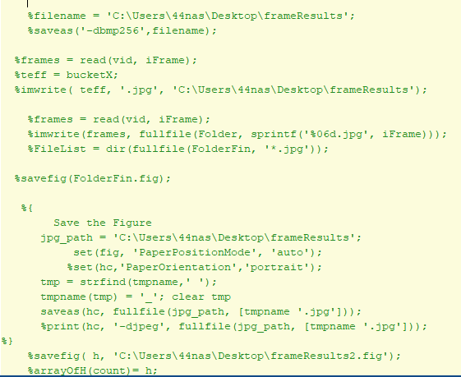

]

ON Friday I was able to sit down and address where the code was getting this random figure from. After that I was able to determine and focus on which Figure I wanted save and where. Then from there I was able to use other code that I pulled from the “video to frames” code and have it count each figure that came through.

That was the last major hump for a working piece of code. Now I just had to grab the data and then run through it with a 1 second pause all together. To give it the affect of it being a regular movie like before. And that was done.

Everything technically works but the only problem is optimizing the code. My computer doesn’t really have the computing power to keep up with a task like this as well my other processes running. To make an analogy the frame and the overall house is built and its live able but there are things to make it a lot better given enough time.

(In the picture below the section uncommented it the working result)

